|  |
| --- |
| Thriving Places |
| Living in Drumchapel |
| Consultation Report, April 2018 |

Morven Clark, Lead Researcher and Report Author

Research Team:

Charles Bailey, Amanda Bell, Liam Gangel, Eilidh Jamieson, Andy Lynch, and Tracy McKenzie

Lead Applicant Organisation: Cernach Housing Association



**Thriving up the Drum**

Are we thriving or are we not?

How do we best use what we have got?

Do we believe we can make some change?

Or think it's not possible and out of range?

The vision of our future, like planning in the past

Must belong to local people if it's going to last

So we must have that vision, belief and self and esteem

Collective action together, like a big Drumchapel team

We should focus on our strengths and learn from the past

Strengthening our community, a true master class

If people make Glasgow, I believe we are the same

Let's move on from the negatives and less focus on blame

It is easy to have words and tell us that you hear us

Then after a while, no one comes near us!

What is so different about the thriving places theme?

The community have identified priorities to transform the scheme

By Amanda and Andy Bell

April 2018

**Introduction**

This report presents the findings of a local consultation with the community of Drumchapel, undertaken by a group of people with strong connections to the area. As the findings of this report will establish, the community of Drumchapel has strong aspirations to see the area thrive and to secure better outcomes for residents, and the best possible future for children and young people growing up. There is a great deal of excellent community activity going on in Drumchapel and an abundant sense of community spirit. The residents we have engaged with and listened to are clear on where action is needed, and which developments are priorities for the future. The findings of this consultation make clear that many residents are experiencing significant isolation and social exclusion. Participants emphasise the need for an accessible community base where local people can gather, be supported, and access opportunities for learning. People want to connect with their community, and there is a strong desire to see Drumchapel thrive.

The findings presented in this report can make a strong contribution to informing future plans for Drumchapel, by exploring local people’s experiences and perceptions of the area in which they live and using these to inform decisions for their community. It is envisaged that this report can contribute to navigating a route through which local people are enabled to make a meaningful contribution to shaping Drumchapel’s future. People who are connected with Drumchapel are the most able to speak to the past successes and disappointments impacting the area, and to know what works best for the area. This report can raise awareness among groups on how best to respond local people's aspirations, and work with them to make positive changes in Drumchapel.

**Background**

***Drumchapel***

As the findings of this report will make clear, a great many people living and working in Drumchapel have a strong passion for the area and a real desire for the area to be the best it can be for people living in the community. The findings also indicate that a considerable number of people experience social and financial hardships, and the detrimental impact to health and wellbeing that accompanies them. The Scottish Index of Multiple Deprivation (SIMD) affirms this. Drumchapel forms 16 data zones within the SIMD (2016). Fifteen of these sixteen data zones are ranked within the 15% most deprived areas in Scotland; eleven of the sixteen data zones are within the 5% most deprived zones in Scotland. Life expectancy of males in Drumchapel is 7 years lower than in Glasgow as a whole, and 8 years lower for women (Glasgow Centre for Population Health, 2016). Drumchapel currently has approximately 13,000 residents, a quarter of who are children aged under 16. Drumchapel's population has declined from around 36,000 historically. Ethnic diversity is less than for Glasgow as a whole, with just 5% of people in Drumchapel from minority ethnic groups. Drumchapel also has a relatively low employment rate, and relatively more local people with disabilities and/or long term illnesses.

While it is out-with the scope of this report to provide a full directory of projects and services operating in Drumchapel, it is important to highlight the array of local projects, groups, services and organisations working locally, and the value that their presence brings to the area. Drumchapel has a rich network of people working in support of the area, including community groups, community and neighbourhood centres, schools, a health centre and five community-based housing associations. Statutory, voluntary and private sector organisations, and a strong network of individual members of the public are actively involved in the local area. [1] There are over 400 private businesses and self-employed local people who run their businesses from Drumchapel.

***Thriving Places Drumchapel***

Thriving Places is a Glasgow City Community Planning Partnership (GCPP) project. In Drumchapel, Thriving Places operates in conjunction with the North West Sector CPP and Glasgow Health and Social Care Partnership’s Health Improvement Team. The development of Thriving Places in Drumchapel and across Glasgow has taken place within a wider national policy backdrop, notably the Community Empowerment (Scotland) Act 2015, which was passed to heighten the capacity for local communities to take a greater say in the decisions that affect them. This Act also requires Community Planning Partnerships to produce Locality Plans for areas that experience disadvantage, including health and wellbeing, access to services, housing, community safety, employment, education or income. The Drumchapel locality plan was produced in October 2017. Most recently, in April 2018, the GCCP published the Glasgow Community Action Plan, which sets out the priorities for communities across the city, informed by local people and agencies’ knowledge and understanding of their own areas. A key facet of this document is the promotion of ‘inclusive growth’ for Glasgow, and the Thriving Places approach is at the heart of this. ‘Place making’ also underpins this ethos of the Plan, an approach which means

*“….having a real dialogue with people who live and work locally, gathering and using their knowledge about how we can shape the local place together and integrate new ideas and services. We know that creating that link between people and place means that we all have a greater stake in its success, want to be part of that place and can improve people’s health, happiness, and wellbeing. It can provide environments which function well, link well with surrounding areas, and provide attractive areas in which to socialise, to move around and to do business.”*

The Thriving Places Drumchapel project was introduced in 2016 to help improve quality of life through measures of health and wellbeing, community safety, education, employment, income, housing, the local environment or access to services. Community engagement is fundamental to the Thriving Places approach. Thriving Places operate in several localities in Glasgow, supported by a team of Community Connectors. In Drumchapel, Cernach Housing Association is the anchor organisation which hosts Thriving Places, providing the Drumchapel Community Connector with an office base and a network of support. Thriving Places Drumchapel also has a short term let of a vacant shop within Drumchapel Shopping Centre which is open to the public to come and find out about the Thriving Places work in their community. Central to the Community Connector's remit is encouraging local involvement in decision making, and bringing services and projects in Drumchapel together to the best advantage of local people. The Community Connector is involved in any endeavour that can make services more accessible, secure the best outcomes for local people, and promote a joined-up approach.

In 2016 the Community Connector invited representatives from a host of local projects, voluntary and statutory, to join a steering consortium of partner agencies to discuss the possibility of submitting a bid to the Aspiring Communities Fund. Soon after, members from; Families Connect at Chesters Nursery School, Drumchapel Community Business, Drumchapel Community Council, Drumhub Community Group, Essenside Church and Friendship House, G15 Youth Project, Drumchapel Foodbank and St Mark’s Church, collaborated to assist the Community Connector in developing a pathway for the creation of a Community Connecting Plan.

The group shared the Thriving Places approach of community involvement and working together for change. Crucially, the consortium of partner agencies was committed to developing effective ways of hearing the voices of the people living and working in Drumchapel, sharing a positive ethos of the area’s existing strengths and community spirit, while also taking a realistic vision of the aspects of the community that need support to improve. The consortium was central to developing the idea of the community consultation, designing and conducting it. Together these partners worked with the Community Connector to make an application to the Aspiring Communities Fund, a joint funding source between the Scottish Government and the European Social Fund. This was successful, and the funding for the current Community Consultation was secured. In late 2017, Thriving Places Glasgow also secured the resource of a short term let on a shop unit in Drumchapel Shopping Centre. The partner agencies worked together to support the furnishing of the shop with movables from a recently closed community centre in Drumchapel. The shop is staffed by the Community Connector, with support from members of the local partner agencies, and is open to the public most weekdays from 10am until 4pm. Local people are visiting the shop regularly and have shown a great deal of interest in the work that is going on with Thriving Places and the associated community consultation. Tea and coffee is offered to all, and information is made available on a range of community organisations, as well as signposting to relevant avenues of advice and support for people who need them.

***The current project: aims, objectives and priorities***

For many years now, Drumchapel has been the subject of a great deal of research work and media attention. Drumchapel is an oft-cited example and point of comparison for local and national discussions of poverty, disadvantage and social exclusion. Much of this work has been undertaken by quantitative researchers who have made significant contributions to establishing the Drumchapel residents’ relative disadvantage in life expectancies, levels of unemployment, educational attainments, health and wellbeing measures, and a great number of other statistical variables. Much less frequently have researchers engaged in qualitative research with people in Drumchapel, to explore their experiences, attitudes and perceptions in their own terms. Rarer still are examples of qualitative engagement designed and conducted by people living or working in Drumchapel themselves. The current work is an important step forward in this regard. The underpinning priority for the current Community Consultation mirrors that of the ‘Placemaking’ approach of the Glasgow Community Plan; “to have a real dialogue with people who live and work locally”. This means hearing local people’s voices, and making people feel as comfortable as possible to report openly and honestly. Furthermore, we feel it imperative that the people asking the questions are able to participate in an authentic engagement with the people they speak with, enabled by sound local knowledge and a strong commitment to the area.

The Community Consultation reported here was undertaken with several key aims:

* To provide an insight into the opinions and experiences of people living in Drumchapel, and to use this information to inform the development of a Community Connecting Plan for Drumchapel
* To give detail on what local people need and want for their local area, from the perspectives of the people themselves
* To engage with people in Drumchapel to promote their participation in their local area’s progress.

As well as working towards these central aims, we also took cognisance of the Locality Plan for Drumchapel, which highlights the barriers local people face consistently, discussed regularly by community groups and with the Community Connector since coming into post. These included;

* Unemployment and in-work poverty, low paid work
* Poverty in general (fuel, food, debt)
* Organisations working separately and not in partnership
* Lack of awareness of activities delivered among/ by organisations
* The need to share the experience and knowledge of long term activists to generate new community participants
* Improving Drumchapel Shopping Centre

With these aims and the above mentioned local priorities in mind we sought to develop a semi- structured questionnaire for use in conversations with local people, with questions informed by both the Locality Plan and discussions with consortium partners.

**Methods and Analysis**

***The research team***

The Thriving Places Consortium was unanimous in the view that the people most able to engage in a Community Consultation about Drumchapel were those who knew the area well. We sought to identify local people with the relevant capacity and experience to undertake face to face interviews with Drumchapel residents, guided by a semi-structured questionnaire. An existing member of the Thriving Places Consortium, representing the Chesters Nursery Family Group, was qualified in social research, managing various research projects in the past. This member was appointed to lead this work on behalf of Thriving Places, adopting the role of lead researcher and authoring this report. Other partner agencies within the Consortium agreed to support the establishment of a small team of local people who had both the skills and the local experience to contribute valuably to the Consultation work. The G15 Youth Project, St Mark’s Church, Drumchapel Community Council, and Drumhub all used their networks of local contacts to form a team of six people who would undertake the task of calling on residents at home, seeking their participation in the interviews. This strand of the exercise took place between early December 2017 and mid-February 2018. The team worked primarily evenings and weekends, around their existing work, study, voluntary and family commitments. For safety, and given that many of the working hours were in darkness we decided that the Consultation fieldwork should be undertaken in pairs. On some occasions, during the daylight hours and in public spaces, some of the team undertook work alone, at their own discretion. The G15 Youth Project, located within Drumchapel Community Centre, often acted as a base for the team, and the project coordinator there assisted the team and the lead researcher significantly in the coordination of the research through provision of an area mapping tool[2], and with practical and administrative support.

Each member of the research team contributed various strengths; those with youth work experience engaged with, and listened to, young people and were familiar with the issues affecting them in Drumchapel. This enabled them to note their hopes and dreams for the future. Other members of the team had experience of working with adults with learning disabilities and mental health issues, which proved valuable. Of most value though was the fact that every member of the research team could engage strongly with people speaking about Drumchapel, because they themselves knew the area. So when people discussed walking routes, bus routes, local amenities, schools, buildings and services (both current and historical), the team members could relate their local knowledge to what people were saying, and ultimately engage in a more meaningful conversation about the area. The team was also able to signpost people towards appropriate avenues of support and information where necessary, and carried information to direct people to local services that could be of help to them.

The lead researcher met with members of the research team prior to the start of the Community Consultation, discussing a range of issues including personal safety, and confirming the lead researcher’s contact details for day and night. Using the Drumchapel area list, adapted from a tool used by the G15 Youth Project’s street work, different areas of Drumchapel were assigned to the various members of the research team, ensuring no duplication of addresses.

***The Questionnaire***

In order to guide our discussions with people in Drumchapel, we developed a semi-structured questionnaire. The Consortium members provided useful suggestions based on their own experiences of living and working in Drumchapel, and these were incorporated into the final draft. Among the additional issues suggested by the Consortium members were questions about; sectarianism, opinions about the future development of unused land in Drumchapel and the experiences of (and attitudes about) people settling in Drumchapel from other countries.

We did not want to confine answers to a pre-determined range but sought to use open questions that would allow people to report their answers in their own words, and left many of the questions ‘open’, for participants to supplement their responses with any other issues or points which they felt relevant. It was also foreseen that some people in Drumchapel may have lost faith with the concept of further research in the area, if they perceived that positive change had not been forthcoming or successful in the past. With this in mind, we felt it important to reaffirm the voluntary nature of participation; there was no obligation to take part, but to stress the importance of engaging and listening to what people in Drumchapel have to say about their own area- positive or negative- and to record this in a way that could direct future changes.

***Consulting the Community***

At the conclusion of the Community Consultation exercise, 299 face-to-face interviews had been conducted by the research team. This strand of the research took place over approximately ten weeks, from early December 2017 to the middle of February 2018. Many of the conversations took place on the doorsteps, or inside people's homes[3]. A number of the interviews were conducted in the Linkwood high rise flats, identified as an important area of Drumchapel to make contact with given the potential for residents there to be excluded or isolated due to their type of housing. Many streets throughout the community were visited, with no access to the main closes on many occasions. Local groups, agencies and buildings were also visited. Interviews took place in the shopping centre, Drumchapel Swimming Pool foyer, the Thriving Places shop, and during parents’ evenings at local schools (in agreement with Head Teachers). Team members visited Fortune Works, Drumchapel Health Centre, the Community Addiction Team, and local retailers.

The planners spent many evenings at the G15 Youth Project ensuring that young people were part of the consultation and listening to their hopes and aspirations for the future. Young people linking in with the G15 Youth Project were asked to participate. A series of events co-facilitated by Thriving Places and the Consortium partner agencies took place and this gave a further opportunity to consult with the community.

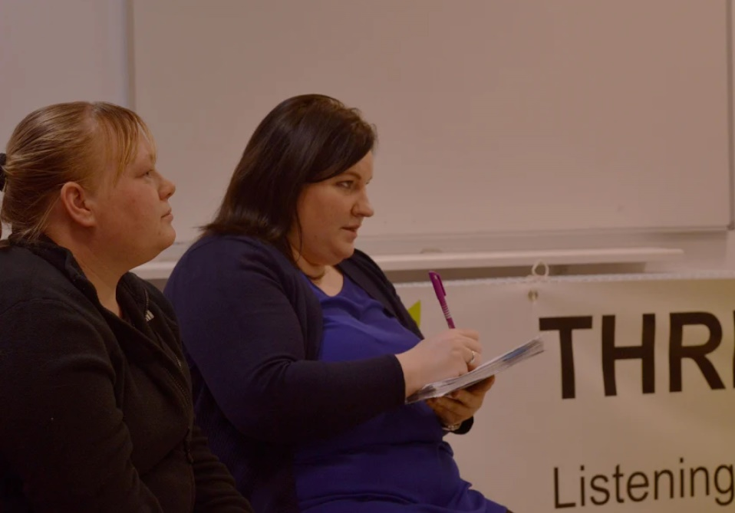

***Community Events***

The research team working on the Community Consultation engaged with community partner agencies to host a series of community participatory events, geared at promoting the community consultation among local people in an inclusive and welcoming forum. These coincided with the door to door consultation work, and were held in the first three months of 2018. Events included;

* Community get-togethers marking Robert Burns Day, Pancake Day and St Patrick’s Day, partnering with Drumhub, a community engagement charity, at Drumchapel Baptist Church

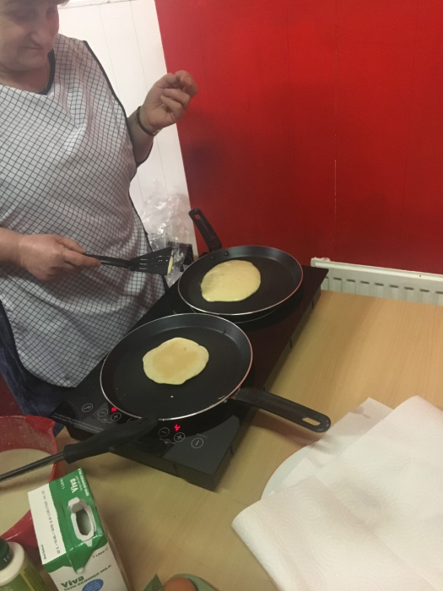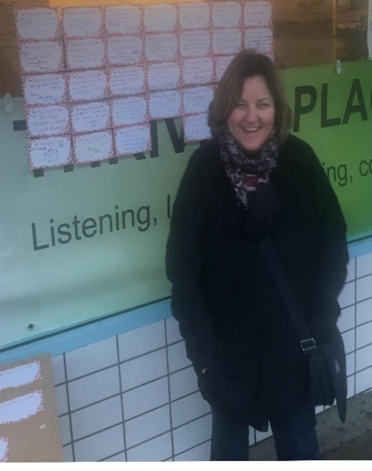

* St Valentine’s Day and Mothers’ Day community engagement events in Drumchapel Shopping Centre, supported by the G15 Youth Project
* Community Heritage picture board displays within the Thriving Places shop in Drumchapel Shopping Centre, in conjunction with Drumchapel D60 community group
* Cooking demonstrations at the Thriving Places shop, in partnership with Axis Health Hubs

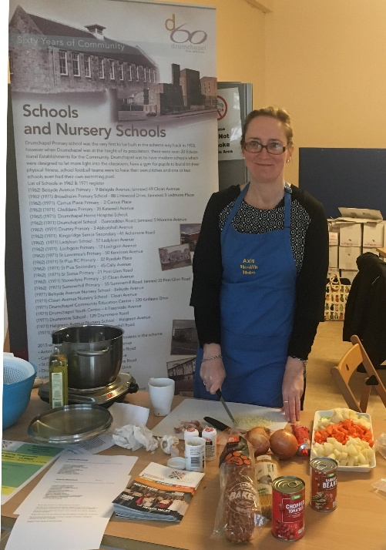

A Tea Dance for local pensioners, supported by St Marks Church, Drumchapel

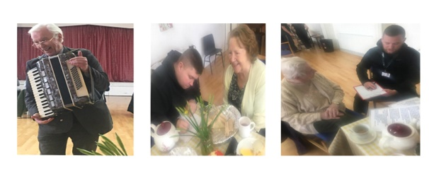

* A Community Consultation Lunch with local people, offered jointly with Drumchapel Food Bank at the Phoenix Centre in Drumchapel
* 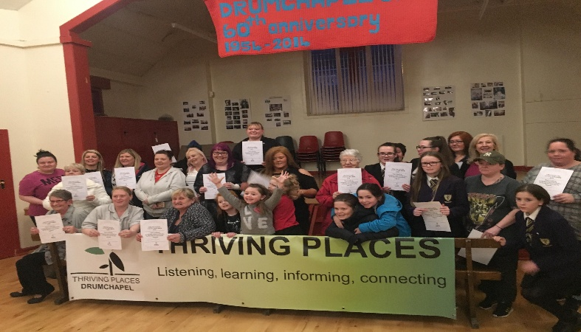Organisation and delivery of the FERO awards in partnership with the G15 youth project to celebrate the achievements and value of women living and working locally

* Community Budgeting event which brought together a range of local groups and organisations who had received awards to further their aims.

The community events were excellent means of reaching larger groups. The events provided a good contrast to the door-to-door element of the consultation but could not substitute the door to-door work, as the most isolated Drumchapel residents were less likely to be accessing community get-togethers. At all of these events, the lead researcher attended with members of the research team to introduce the Consultation and to invite the people at the events to participate. People were generally very keen to learn about the consultation and prepared to take part. A number of participants suggested that the team should return at later events to keep the community up to date on the progress of the consultation. The research team and the Thriving Places consortium agreed this was an excellent suggestion and have made note of this in our future plans for dissemination of the findings of our Consultation.

***Online survey***

A further strand of the community consultation exercise was the development and distribution of an online version of the questionnaire. The Consortium and the research team considered that the presence of an online survey would widen the reach of the research across Drumchapel, and provide some statistical data to complement the mainly qualitative approach of the semi-structured face-to-face discussions. The staff of the G15 Youth Project assisted the research team in adapting the questionnaire to an online format, sharing it widely with their large network of local contacts through social media. The online survey was also supported by Drumchapel Community Council, Drumhub, Chesters Nursery Family Group and Drumchapel D60, all of whom made links to the survey available to people living in Drumchapel via their Facebook pages. The survey ran for one month, from mid-February to mid-March 2018, with a participant sample of 150 people.

***Taking Stock***

The researcher reviewed the scope and reach of the work of the community consultation wherever possible, engaging in feedback and discussion with the research team, Community Connector and the consortium of partner agencies on a regular basis. Feedback from participants, Drumchapel residents and people working locally was very welcome and often forthcoming. Led by the local Health Improvement Team, the ‘Breakfast and Blether’ forum is an established network which brings people working in and around Drumchapel together, with representation from health improvement, education, housing, community groups and the voluntary sector. The lead researcher made presentations at these events in December 2017 and March 2018 to inform people working locally of the work of Thriving Places, the Community Consultation, and the participatory events. This was an opportunity to answer questions and take on board feedback. These events garnered excellent suggestions about how the findings could be disseminated, and local organisations were invariably supportive in their comments. At these events some early indications of the findings of the research work were relayed to those in attendance, and there was a strong sense of commitment by local agencies to acting on the findings and relay them to their wider networks.

***Data Analysis***

Taking a collaborative approach to the analysis of the data was a priority for the Community Consultation research, mirroring the approach all other aspects of the research design and conduct. The community planners and the lead researcher had spent several months immersed in the work, and each member of the team had valuable insights to share, both in terms of experiences of conducting the research, as well on the dominant themes to emerge from the 299 recorded conversations with people in Drumchapel. The team met regularly throughout all stages of the fieldwork to share experiences, discuss what was working well and which aspects proved challenging. The team met to share experiences which we found difficult, including the seldom but very significant occasions where local people were hostile or aggressive, and the times when the team members encountered people who were desperately lonely or vulnerable.

The process of analysis involved members of the research team working together to organise our large volume of qualitative data recorded across the 299 scripts into smaller subsets of data. The lead researcher read through each script and identified themes. The team worked together in intensive discussions to verify and refine these themes, and to identify linkages across the data. and then undertook close reading of the scripts, identifying and highlighting data within the themes.

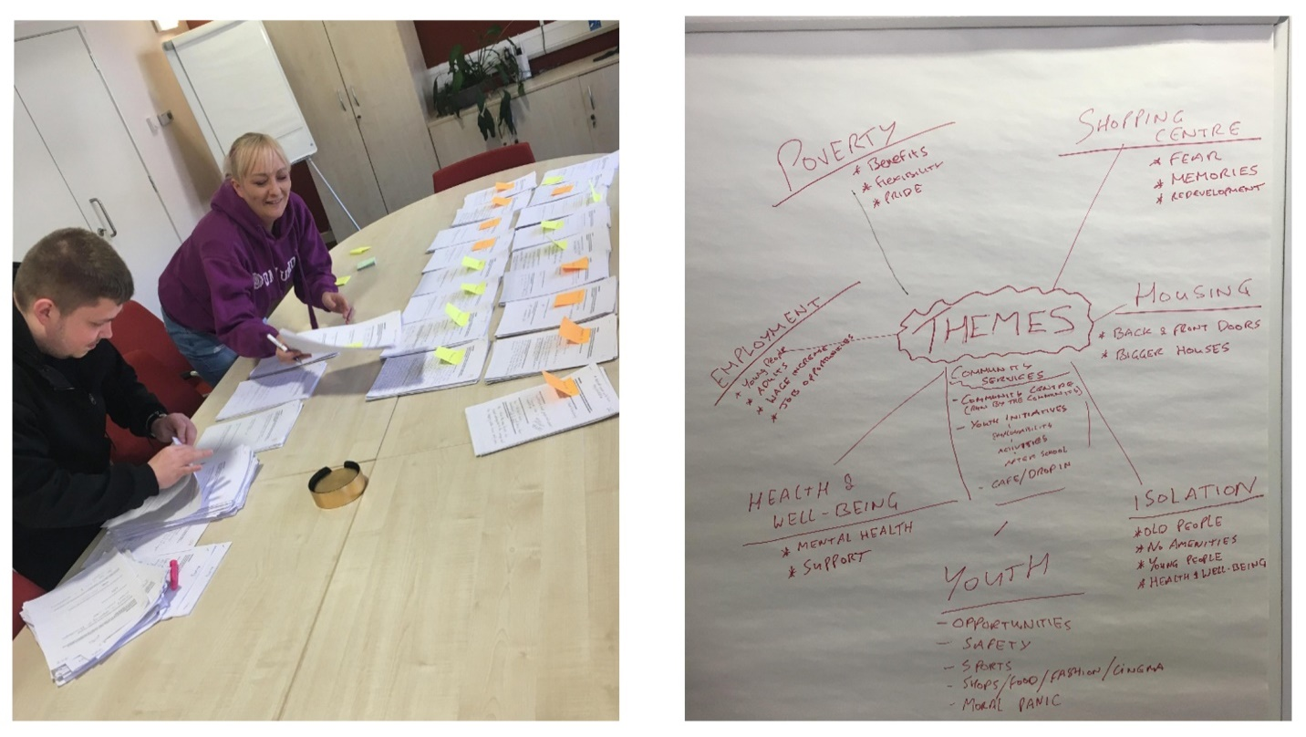

***The Sample***

Participating in the research was confidential and anonymous, and we did not record the participants’ names or addresses.[4] However, we did consider of value obtaining some basic demographic statistics to provide context on our research sample. There was a balanced spread of age categories across our sample of participants. We were also encouraged to see a balance in people who had lived in Drumchapel over the course of many decades, as well as those who had lived in the area for a relatively short number of years, or even months. The tables below outline the gender, age and length of residency of the research sample. In the subsequent sections, the findings are presented using the themes of our analysis for ease of presentation.

|  |  |
| --- | --- |
| **Gender** | **No. of People** |
| Female | 175 |
| Male | 115 |
| Prefer not to say | 4 |
| N/A | 5 |

|  |  |
| --- | --- |
| **Age Range** | **No. of People** |
| Under 18 | 38 |
| 18-25 | 37 |
| 26-35 | 84 |
| 36-45 | 36 |
| 46-55 | 39 |
| 56-65 | 38 |
| 66-85 | 22 |
| 85+ | 0 |
| N/A | 5 |

|  |  |
| --- | --- |
| **Length Of Residency (In years)** | **No. of People** |
| 0-10 | 55 |
| 11-20 | 77 |
| 21-30 | 49 |
| 31-40 | 40 |
| 41-50 | 27 |
| 51-60 | 9 |
| 61+ | 11 |
| N/A | 31 |

**Findings**

The subsequent sections of this report present the dominant findings of our Community Consultation, citing word-for-word quotations from the participants to illustrate the issues arising. The findings presented here using the themes identified by the research team throughout the consultation and in our analysis workshop, as being the most prominent across the data. These are:

* Poverty, deprivation and social exclusion
* Health, wellbeing and isolation
* Housing
* Shops and Amenities
* Unused Land
* Employment and Training
* Ethnicity and Culture

The following sections also give detail of the findings to emerge from the online survey, presenting some statistical data to contextualise the strength of feeling on particular issues.

***Poverty, deprivation and social exclusion***

In considering the approach of the questionnaire, we deemed issues of poverty, the costs of living, and financial issues to be important questions to ask. We also considered how sensitive these topics can be. People’s financial circumstances are highly personal, with issues of pride, privacy, with feelings of judgement likely to abound. Nonetheless, we asked the participants directly about poverty and hardship, in as sensitive a manner as possible. In responding to the question of whether it is hard to make ends, 52% of the online survey respondents reported ‘yes’;

*“I have always struggled to make ends meet. I am on JSA and treated poorly every*

*week.”*

*“I am only ever 4 weeks from financial disaster. I have no savings if anything goes wrong.”*

‘Getting by’ and ‘just about surviving’ were common responses to this question. It is worthy of note that the Community Consultation coincided with the Christmas holidays and the ‘aftermath’ of January and early February. Several participants explained that this was a particularly difficult time for them and many others in the community as they struggled to afford the cost of the celebrations and gifts for their families. Many participants highlighted that poverty is evident all around the area and knew that their friends, families and neighbours in the area were experiencing issues with money, even if they themselves did not report experiencing financial hardship or deprivation. The stress, anxiety and discontent surrounding financial hardship were evident in the data. A number of participants reported that their financial situation was a source of significant stress and anxiety from which it was hard to escape. Financial hardship was also linked with feelings of isolation and exclusion, for participants and their families;

*"The kids are hanging around with nothing to do. I need to take them places but with no*

*money it’s hard and I feel terrible."*

While almost all participants acknowledged poverty to be a prominent issue impacting upon many residents in Drumchapel, a number of participants explained the impact of ‘labelling’ the area as disadvantaged or excluded, and the consequences of this to the self-esteem and identity of the people living in a place where labels and negative perceptions are applied:

*“People are bogged down by stereotypes, when you are told something over and over*

*eventually you start to believe it.”*

*“Our area has a terrible stigma attached to it.”*

*“Labelling is an issue in Drumchapel, and it has a psychological impact.”*

This is an interesting finding, reported prominently across the data. The research team reflected a great deal on this and considered the impact of living in a place which was labelled in this way. There is potential for this to constrain and curtail the ambition and self-confidence of people growing up in Drumchapel in terms of what people from ‘outside’ think of them. It was considered that this could impact negatively upon what people growing up in Drumchapel believe is achievable for them and what people from ‘outside’ believe they can achieve. Participants made links between the issues of stereotypes/labelling, and Drumchapel’s physical appearance. Some residents pointed out that, negative labels could be applied to Drumchapel because of the appearance of local amenities, primarily the shopping centre and derelict land.

***Shops and Amenities***

As well as being the primary retail hub in Drumchapel, the shopping centre at Kinfauns Drive and Hecla Avenue houses the main Post Office in the area, as well as Drumchapel's only branch of a major bank (the TSB). The shopping centre neighbours Drumchapel Library, Drumchapel Health Centre, Drumchapel Park, the local taxi rank and the main bus stops for services in and out of Drumchapel to Clydebank and Glasgow City Centre. Much of the original structure has been demolished and the number of occupied retail units has decreased significantly in recent years, leaving a large swathe of derelict land. Participants in our study argued that the shopping centre and the surrounding facilities are more than just local amenities; they are visual representations of the area. Almost all participants were familiar with the local shopping centre, and used some aspect of it or a neighbouring amenity, and almost all cited the decline of the amenities there and a worsening of the local environment. This decline has prompted deep consequences for how local people feel Drumchapel is represented to those living both inside and outside of the area. This extended the level of concern beyond just the loss of amenities which existed before; participants articulate the damage the shopping centre’s decline has had on their self-image and how they feel other people from outside perceive *people* in Drumchapel, rather than merely the buildings and amenities:

*“The shopping centre does not present a proud community, but WE ARE!”*

*“Local facilities make this area look down and out, like we are down and outs.”*

*“Look at the state of the shops, it looks like we don’t care, but we do care."*

*"This shopping centre depresses me.”*

*“Just look around this shopping centre….what does this say to people about Drumchapel? It looks poor and empty, that’s what. Drug dealers and users rule this area. It’s dangerous and you can see disadvantage everywhere.”*

*"John Oliver is good at putting into the community but there are all these businesses and none of them contribute to the community to make it better."*

The shopping centre was cited overwhelmingly in relation to a whole range of points of view; to illustrate disadvantage, damage to civic pride, fear for personal safety, and lack of amenities. Participants who did *not* express concern or dissatisfaction with the shopping centre were in the minority. Older participants stressed how inviting the shopping centre once was, not only as a place to choose from a wide variety of shops and stores, but to gather with others in the community and enjoy the surroundings which included a play park, café, fountain, and staffed toilet facilities. Even participants currently aged in their thirties recall the shopping centre as a place that was bustling with people, used by everyone locally. The research team undertook the task of photographing around the area, and there were some notable contrasts to be made. In the subsequent photographs the additional lighting provided by the overhanging shop lighting, made the shopping centre appear significantly brighter in the past. The discoloration of the pavements also appears to have contributed to a decline in the appearance of the main precincts.



Photographs taken at the Kinfauns Drive precinct of Drumchapel Shopping centre, the latter 2018 and the first approximately 25 years earlier. Photo by David Holgate, made available with permission from Drumchapel D60 for the purpose of illustration, recent photo Amanda Bell.

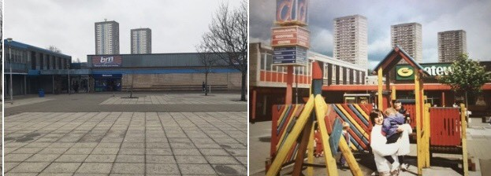

Drumchapel shopping centre formerly had additional amenities such as children's playparks and public toilets, these have been removed and large expanses of concreted areas are now in their place. Credits; David Holgate and Amanda Bell

In the online survey, improving the shopping centre was the most frequently cited change participants felt is needed to enable Drumchapel to move forward, more than any other response. In setting out the specifics of how the shopping should be improved, participants most commonly cited the issues of loitering and their perception of risk to their personal safety from those loitering. That people were uneasy and cautious of their personal safety in and around the shopping centre was a pervasive finding across the data. There was also a call for a wider range of shops to fill the number of vacant units in what remains of the original shopping centre[5] as well as seating areas where people can sit and chat.

***Health, Wellbeing and Isolation***

Asking people directly about their health was a complicated aspect of the study. Like finances, speaking of health and wellbeing is a sensitive topic for many. Furthermore, many people, particularly older people, appeared stoic about their health and wellbeing, and perhaps reluctant to acknowledge where they might be struggling. It is well established that much stigma is attached to discussing our health and wellbeing. Discussing mental health and wellbeing remains taboo for many people in Glasgow, with ongoing stigma and shame attached to these issues. Drumchapel residents were no different. Many people do not want to be seen to be complaining. Despite these potential challenges in reporting issues related to health and wellbeing, it was very apparent that these issues had a profound effect on participants in our study. Participants reported a variety of issues related to their health and wellbeing, and those impacting their children and families. Some participants were undertaking caring roles for ill family members, while also dealing with health challenges of their own. The issue of addiction also emerged prominently in the community's perspectives. In the main, this was reported as a problem preventing people feeling safe in public spaces such as the shopping centre. In a smaller number of responses, participants reported their own addictions as problematic and contributing to their social exclusion and poor health and wellbeing.

As well as citing some of the ways in which their health and wellbeing were impeded by specific illnesses, a number of participants were insightful into what was *causing* their health and wellbeing to be challenged. Some made linkages between their standard of health and wellbeing, and the extent to which they were connected from their community and the people around them:

*“I feel like a prisoner in my own home sometimes, it's not good for me.”*

*“I am suffering depression, probably associated with the isolation.”*

*“I wish I had a front door so I could sit outside and see folk, up the flats you can’t do that and it's not sociable.”*

*“I need company. I can go weeks without seeing anyone. It has a big effect on my mental health.”*

*"I have a front and back door but I miss my neighbours, I don't know anyone in my street."*

This link between isolation and adverse impacts to health is a key and consistent theme and one which crosscuts the entire data set. People spoke about the impact of isolation in respect of virtually every theme; from housing as a source of isolation, to isolation caused by financial hardship, poor health and wellbeing. In this study, the participants who described being connected to the community appear to have a greater sense of contentment and spoke more positively of their wellbeing and the presence of things in their life that brought them satisfaction. To say that those participants who feel connected to the community are experiencing better health and wellbeing is too bold a claim for the findings of our work here to support, but there is certainly a sense that linking in with local groups, community, and neighbours contributes positively to a sense of connectedness and inclusion that enhances the wellbeing of local people. This was evident in speaking to Drumchapel residents engaging in a whole range of local activities and services, many of which are offered free of charge;

* Community walking groups
* Park runs in the Garscadden Woods which border the North edge of Drumchapel
* Youth clubs
* Cycling groups
* Sewing Groups
* Art Workshops

Indeed, it was striking to observe that the participants we consulted at community participatory events reported the benefit they secured from participating regularly in their community. In our discussions of isolation and community connections locally, people were emphatic that local community groups and meeting places are vital. Where people were linking in with local groups, they were overwhelmingly positive about the experience, and it is clear that the collaboration of local groups operating locally has great meaning to people in Drumchapel. It is also clear that the range of community groups in Drumchapel is of a high quality, attracting people along and seeing them return again and again. This was particularly the case for children and young people.



Children playing at Drumhub Community group during the February 2018 school holiday.

However, one third of respondents of the online survey reported not linking in with any service or agency in Drumchapel at all, and participants in our face-to-face interviews, who reported loneliness and isolation, said that they were unsure of where and how they could link in with things going on in Drumchapel. A desire to see a community hub was central to participants’ views on the area. Participants cited a great number of places and hubs that existed in the past where the community was able to get together, and the dearth of venues in which to do this at present. There appears to be a strong local appetite for a community centre where local people have a central role in developing what is offered to the local community. Suggestions from the data included an affordable café, men's groups, women's groups, and drop in sessions targeted at specific age groups, youth initiatives and health and fitness sessions;

*“We need a community hub with activities for all ages.”*

*"We need a community garden, outside space to get together, I would love that."*

Evidencing the local appetite for a community hub in Drumchapel is the response of local people to the Thriving Places shop in the shopping centre. In the four months the shop has been open, a number of local people have taken to visiting the shop regularly and people passing in the precinct stop to look at the signage and window displays. People coming into the shop have participated in cooking workshops and sampling of freshly prepared food, linked in with other local groups and organisations as a result of signposting from the shop, and a considerable number has come in seeking information about what is going on locally and how they can engage with developments in the community.

***Housing***

According to Drumchapel’s Locality Plan, some 74% of all housing in Drumchapel is socially rented, managed by several local housing associations operating in the area. Drumchapel underwent a radical programme of housing regeneration in the early 2000s, wherein the existing housing stock of the original tenements built in the 1950s was demolished and replaced with a mix of new flats and houses.

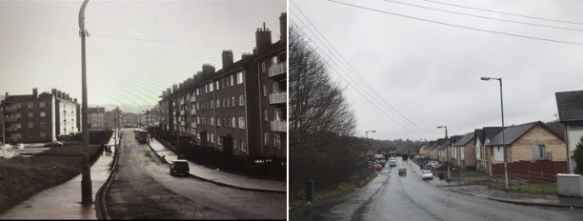

This saw a drastic improvement to standards of living; many of the demolished flats had longstanding issues of chronic dampness and decay. Consequently, many people in Drumchapel live in housing which is relatively new, and of a much-improved standard. Participants in our study acknowledged this; many could recall the issues of the past and the reality of living in housing that was cold, damp and unfit for habitation. We heard few reports of these issues in our study, but the fact that some residents did have ongoing issues with dampness means the issue has not been eradicated entirely. People had much to say about local housing; many participants reported that their current housing had inadequate space for their needs. This was particularly the case for young families, and adults with older children staying with them awaiting a house of their own. Some residents were on lists to transfer to new accommodation but were aware that many years could pass before a suitable property became available. Several residents of the high flats felt that the format of their housing left them vulnerable to isolation and made it difficult to enter and exit their homes safely. This was particularly challenging for those with mobility issues. It is noteworthy that 75% of respondents to the online survey said that they planned to remain in Drumchapel in the years to come. The research did not evidence a desire among local people to leave Drumchapel, but instead found a desire to see the area prosper and improve.

***Community Decisions***

Both the Drumchapel Locality Plan and the Glasgow Community Plan cite the imperative for local participation in decision making, and for local people to have a meaningful say in the matters that affect their communities. In the current research we sought to explore people’s perceptions about how decisions about Drumchapel are made, and by whom. Participants were asked for their views on who made the important decisions for Drumchapel. Two thirds of participants in the online survey reported that elected political representatives such as local councillors, MSPs and MPs made most decisions. When speaking face to face with the participants, many were unsure of how to answer, and said that they did not know. Some recalled that, in the past, there seemed to be greater capacity for local people to participate in decision making;

*“Back in the day, there were people who made decisions about this area who actually*

*lived here and they would get things done. If you needed something done you would see*

*them about it.”*

A number of people reported feeling a disconnection with local politicians at all levels, and what the responsibilities and remits of elected members are. There were also strongly held views on party politics, and we were mindful of this in ensuring that our work took no party-political allegiance that might encourage or discourage any resident from engaging with the work of the Community Consultation and with Thriving Places based on their perception of this. Some participants suggested that more could be done to enhance the engagement of the elected political members, with the people of Drumchapel;

*"Politicians don't engage well enough with the community here."*

*"We should have a question time or a hustings event for the community so people can*

*get answers."*

***Unused Land***

The demolition of the 1950s tenement blocks during the housing redevelopment of the 2000s, alongside the closure, demolition and relocation of various schools and public buildings has left large pockets of unused land throughout Drumchapel. Work is currently underway to construct new housing for the social rented sector in two large plots of land in Drumchapel, but expansive areas of unused land remain.

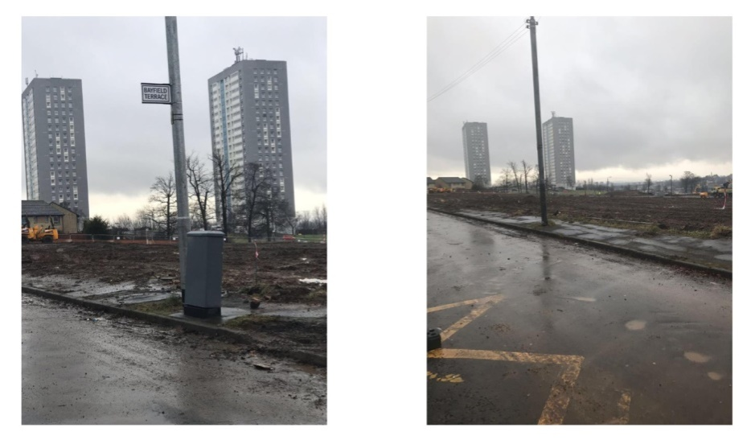

*Work beginning to prepare the land for housing developments in Drumchapel; according to the Drumchapel Locality Plan the new developments could extend to some 1100 housing units.*

The consultation exercise sought local opinions on whether and how this land should be developed. Allied with the finding that local people are seeking further availability of family housing in Drumchapel, approximately half of respondents in the online survey reported that the development of new housing should be the first priority in redeveloping the unused land in Drumchapel.

|  |  |
| --- | --- |
| Category | No. of People |
| New Housing | 72 |
| New Parks/Activity Space/ Sports Space | 35 |
| Play Areas for Kids | 18 |
| New Shops | 17 |
| New Community Centres / Youth Clubs | 11 |
| Gardening Projects / Allotment Space | 4 |
| Leave the space alone | 2 |
| A Secure Dog Park | 2 |
| Other | 3 |

The use of the land for further public amenities was also central to local people’s view on this issue, and in the face-to-face conversations, residents stressed the requirement for further safe spaces for children to play, and for residents to enjoy outdoor space and gardens. Young people suggested areas for playing sports would be advantageous.

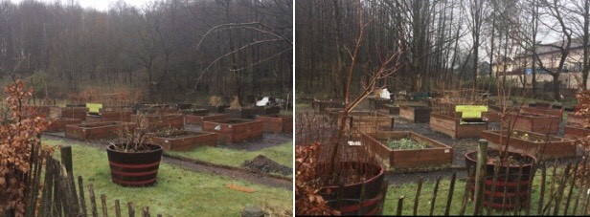

An example of a Community Garden in Northmuir, Drumchapel, off Summerhill Road, March 2018

‘Green infrastructure’ is set out in the 2018 Glasgow Community Plan as a priority for communities across the city and a number of participants in the current Community Consultation echoed the benefit of promoting the use of outdoor local areas for the purposes of planting and growing both to enhance the aesthetic of the area and to provide local people with the opportunity to take part in making improvements to the area.

***Employment and Training***

The Drumchapel Thriving Place Locality Plan, published in 2017, cites investment in improving local people's skills through access to training and education as an immediate priority. The stated aim for 2020 is to secure an established programme of local training and education opportunities, under local control in Drumchapel. In view of this, we asked the participants about their past and current experiences of education, training and employment, and of job interviews. A great deal of discussion on employment and training centred around the requirement for locally accessible options to develop skills. Allied with the call for a community hub, participants in our research argued that community learning provision was much needed, and a perceived dearth of locally accessible training opportunities was highlighted;

*“I would like to see a community college or school, for adults, in Drumchapel.”*

*“We need a community college, and get down to that shopping centre and educate*

*kids about drugs and alcohol.”*

*“Community schooling is needed, to help young men looking for skills for work.”*

A number of participants reported having negative experiences with all aspects of job seeking; from their contact with the Job Centre, to difficulties in making applications for work and performing well at interviews and assessments. For some participants in our study, there was an evident link between the activities required of them as they sought out opportunities for work, and their health and wellbeing:

*“I suffer from anxiety and depression and this does not help in finding a job.”*

*“I need to look for work soon, I am dreading it, and I am scared of the outcome.”*

These findings point to a requirement for increased support and information for local people in their experiences of employment and training, and an examination of the feasibility of offering training and lifelong learning opportunities within the community.

***Ethnicity***

Most of the people consulted in this study appeared to be tolerant and hospitable and generally very welcoming to people settling in Drumchapel from other countries in recent years. Participants were varied in their views on inclusion of people from other countries; some participants were ambivalent to the idea, and while seeking new people no harm, did not have a strong commitment to integration or learning of new cultures. A minority of participants reported feeling hostile to the integration of people from outside the UK. Many respondents highlighted the presence of people from other ethnic backgrounds in Drumchapel as positive, and some suggested that more could be organised locally to support integration and to help people to get to know new people in the area. There was much evidence of a positive stance on the integration and welcoming of people from other countries:

*"I think we are mostly a welcoming community and it's great to have different nationalities within our area."*

*"Education about integration would be useful for everyone."*

*"It’s nice that people want to come here and experience the culture."*

*"I see people from ethnic minorities attending Drumchapel events and that’s nice to see."*

A small number of participants were new to Drumchapel, having arrived from other countries including Bolivia, Iraq, Somalia and Poland. Happily, the reports from these participants depicted a welcoming community who had supported integration of new people into the community;

*"I am new here, people are kind and they help my family."*

Simultaneously though, there was a prominent perception reported across the data, of people 'coming in' and taking resources that are not available to established residents. We found no evidence of this attitude culminating in harassment or intimidation, but there was a clear and evident perception among a number of the participants that people settling in Drumchapel from other countries are disproportionally advantaged in their access to housing, public finances, jobs and training*.*

*“Immigrants get treated better and get a better quality of living.”*

*“Foreign people are getting more support than locals are.”*

*“There are too many homeless people in Glasgow and they are the ones who*

*should be getting priority in housing.”*

*“Immigrants are stealing our weans’ jobs. They are given all the help and we are left*

*with nothing.”*

These findings are interesting and of some concern as they point to divisions in the community that have the potential to widen and become problematic. There is clearly concern among people locally which is related to the scarcity of resources, including housing, employment and social and financial assistance. Being mindful of the presence of these concerns, and their potential for creating discord, is important.

**Discussion and Conclusions**

The subsequent sections conclude the report, contextualising the dominant findings within a wider context of policy and research. The report then makes a series of recommendations, informed by the perspectives of the people consulted with over the course of the Community Consultation.

Our findings show that a great many people living in Drumchapel have a passion for their community and wish to continue living in the area and see Drumchapel prosper. Many people have deep rooted links to the area through family networks both current and historical, a pride in the area they come from, and an investment in making it better for children and future generations:

*“I love Drumchapel and it will always be home.”*

*“I am happy, settled and enjoy living in Drumchapel. I really can’t think of anything*

*that would make me happier. I have lived here all my life and have no intentions of ever*

*moving.”*

*“I would never leave Drumchapel because generations of my family have lived here and still do.”*

*“I want my kids and grandkids to have a future here.”*

Thinking of the outcomes for the future generations was clearly in the forefront of the minds of the people consulted. Far from wishing to see family members exit the area, people are actively looking to engage on how to make Drumchapel the best possible place where they can grow up. This means planning for new local amenities, and nurturing the community cohesion and community safety.

The data collected demonstrates that, for a range of reasons, life in Drumchapel presents many challenges. The participants in our survey reported that many people around them are struggling with financial and social hardships. The appearance of Drumchapel’s public spaces, primarily the shopping centre and surrounding areas, are in decline, and this is a significant concern to people locally. It cannot be emphasised strongly enough how much local people desire improvements to Drumchapel Shopping Centre. It is a deeply emotive local issue. People are describing fear and reluctance to use the shopping centre as they perceive the place to be unsafe. There is also a strong sense of shame and concern that the shopping centre portrays a negative representation of the area both to Drumchapel residents and people outside.

Of much concern is the finding that people of all ages feel unnerved, vulnerable, and unsafe when using the shopping centre. For people who are socially isolated, this may be a significant exacerbating factor. Isolation may also be causally linked with the reports of people feeling disconnected from local decision making, and from the people they believe make the decisions. This disconnection points to a need to think innovatively about how local decision-making processes can be made most accessible to local people, enabling them to take a meaningful part in the decisions shaping Drumchapel.

Detriments to health and wellbeing were reported widely across the data, and in many of the conversations which took place, people reported experiencing poor mental health. This included depression, stress and anxiety, and further manifestations of these issues were isolation and social exclusion. These manifestations can perpetuate a 'vicious cycle' of isolation and poor mental health, and an awareness among some participants that their wellbeing was being impacted negatively by their experience of the place where they live;

*“I would like to learn how to cope with the stress that comes with living here. I don’t like*

*this area any more. There are no jobs and it’s getting worse.”*

There is a wealth of seminal research evidence and theory into which our findings and analysis can be contextualised. The former Chief Medical Officer for Scotland and noted Glaswegian surgeon Professor Sir Harry Burns has focused much of his expert attention to theories of ‘wellness’ and social connectedness in relation to our health and wellbeing. Essentially, where stress is manageable and we have control over our lives and surroundings, outcomes for people are better. Where things feel out of control; our health, families, our finances, we do not do well. Sir Harry’s theses situate a causal relationship between isolation and poor health; for adults and for children. People we spoke with want things to be better for their children as they grow up in Drumchapel. This entails a focus on the early years, looking ahead to new generations to make the future brighter and improve outlooks for children;

*“Kids who leave school have fewer life chances if they come from Drumchapel.”*

There is burgeoning national and international research on linkages between adverse childhood experiences (ACES) and diminished outcomes in all measures of health and wellbeing in adolescence and later life. The evidence supporting this link is prompting national policy action in Scotland (Health Scotland, 2017); challenging adverse childhood experiences is central to the Scottish Government’s programme for Scotland 2017-18. In 2018 3D Drumchapel hosted a conference for professionals locally, where the links between positive/negative childhood experiences and later outcomes for health and wellbeing were set out. Current thinking on how Drumchapel can be developed most positively in the years to come can be valuably informed by considering the experiences of the children and young people growing up here. This means we have to build strong and nurturing communities for the children in Drumchapel, with a real commitment to tackling the issues of social isolation, improving public amenities and providing accessible community connecting hubs, as have been highlighted by the participants of this current Consultation.

**Limitations**

The research team worked intensively to consult with local people in a meaningful way. It was important for us to spend time face-to-face with people, and to answer questions and signpost them wherever possible. This was a time intensive approach, which meant the research team spent longer with each participant than might have been the case with other methods. It is recognised that the research sample is relatively small; 299 semi structured interviews of varying lengths, and 150 online survey responses. While these numbers reflect a positive engagement with the local community, the sample size is small relative to the population of the area. Consequently, there are limits to how reliably the findings can be generalised to the wider population of Drumchapel. We do feel however, that this method enabled us to really engage with people and hear their voices in a way in which simply distributing questionnaires through letterboxes would not have allowed.

**Recommendations**

* The findings of this report must be made accessible to as broad an audience as possible, and crucially to Drumchapel residents. This could be by way of a community conference, where local people are invited to hear our findings. Preparing a video documenting the findings would also be an effective means of communicating our findings to a wider audience, in an accessible format. Social media networks among the partner agencies are extensive and could be a valuable and effective means of sharing the video. There would also be great value in returning to the areas where door-to-door work was undertaken, and re-visiting people who are particularly isolated and less likely to be connected to social media
* The findings can and should inform the upcoming Community Connecting Plan for Drumchapel, shaping future decisions around local voices and points of view, and providing a roadmap for linking up and coordinating local agencies to the best advantage of local people.
* Isolation is a seminal theme to emerge from our work. The impact of social isolation on people living in Drumchapel should take prominence in any decision making and planning taking place locally. Isolation is further reaching than some may anticipate, and the effects extend across all age groups. We found isolation to be interlinked with health and housing, and a number of people cited the scarcity of accessible community hubs as an exacerbating factor
* There is a local demand for a community hub in Drumchapel. The presence of the Thriving Places shop front at Drumchapel Shopping Centre offers new opportunities to continue with the community engagement work that we have undertaken here. People are coming into the shop, and they are returning. We could use this as a means of establishing new modes of engagement with the community, and to signpost people to the existing projects, services, groups etc. that are already operating in Drumchapel and nearby.
* Participants highlight the issue of labelling in Drumchapel and the impact of negative stereotypes being applied to the area. Where local facilities do not reflect a proud appearance, these stereotypes are applied more easily, and this has a significant impact on the collective self-esteem of the area, and minimises the capacity for Drumchapel to celebrate the positive aspects of the community.

**Appendix 1: Reflections on the Community Consultation exercise by Amanda Bell**

Being part of the Thriving Places community team in Drumchapel has been invaluable and inspirational, providing me with a really positive learning experience. Coming from the local area, I felt a very strong sense of pride about the community and I really appreciated having the opportunity to get out there, meet new people and learn more about Drumchapel and what it means to be part of this community.

My colleagues and I used a variety of qualitative research methods to gather information from local residents such as door-to-door discussions, questionnaires and online surveys. I focused on direct communication methods such as door-to-door discussions with local people about what they would like to see change within their area. By using this method, I had the opportunity to signpost people to a variety of services within the local area for advice and support. I personally felt that local residents appreciated that their views were taken on board and valued. I met with some people who were socially isolated, with little or no support and very rarely leaving their homes. There was a mixture of age, gender and areas, however all were lonely said they lacked the confidence to get involved within their communities. This is something that needs to be addressed to ensure that all the residents feel part of this community. Despite this, many local residents were keen to get involved and were really enthusiastic, making the experience for everyone more fun; I certainly enjoyed having a wee blether!

Drumchapel is full of people who are passionate, committed and determined for the community to continue being a thriving place to live, learn and work. The young people of this community are creative, inspirational and proud of where they come from- thriving places is about ensuring that this creativity is nurtured and Drumchapel can continue to be the community for all.

Amanda Bell

March 2018

**Appendix 2: Reflections on the Community Consultation exercise by Liam Gangel**

I have had different experiences of my time working with Thriving Places which have opened my eyes to what’s going on in and around my community and also local people’s points of view on what they felt is happening in their community and what they want to see happen.

A positive is getting to speak to new people whom I may not have spoken to before who have great ideas and listening to their points of view. It also opened my eyes to how many ethnicities there are in Drumchapel. A huge negative which got me thinking a lot what how many people felt they had no say in what happens in Drumchapel. Also the amount of people who are scared to leave their homes to go and do everyday things like go to the shop or be scared to go to the bank as there are no lights where they stayed and also scared to go near the shopping centre because of certain people who congregated near the shops they need and want to use.

To conclude, I feel being local has helped hugely in this process as gaining that connection to Drumchapel with other people have them that knowledge that I am local and it breaks down the boundaries.

Liam Gangel, March 2018

**Appendix 3: Reflections on the Community Consultation exercise by Charles Bailey**

My experience of working as a community planner in Drumchapel for Thriving Places has had its ups and downs. Recently graduating with a degree in community development has assisted me in putting my skills and learning methods to good use.

The positive aspects for me were on a more personal note, by establishing trusting relationships with local people, I improved and built on my confidence and skill of communication. It was great using an asset-based community development approach when investigating my own community. This was done through facilitating questionnaires with residents of Drumchapel and hearing people’s views of the changes they would like to see over the next ten years. As a team we did door to door enquiries and interviewed local people from a variety of ages and diversities to provide us with an array of different thoughts and examples of daily challenges and beneficial amenities that they face and utilise on a regular basis. Another outcome that we achieved was completing ethnographic research and analysing the data collected.

Charles Bailey, March 2018

**Appendix 4: Area Mapping Tool, adapted from zoning tool used by the G15 Youth Project**

|  |  |  |  |
| --- | --- | --- | --- |
| **AREA 1** | **AREA 2** | **AREA 3** | **AREA 4** |
| **Peelglen Road** | Kilcloy ave | Millenium court | Kinfauns drive |
| **Peelglen gardens** | Ladyloan ave | Kendoon ave | Glenkirk drive |
| **Drummore road** | Ladyloan gardens | Halgreen ave | Claon ave |
| **Summerhill road** | Lochgoin ave | Abbotshall ave | Belsyde ave |
| **Bellway** | Achemore road | Argo centre | Boon drive |
| **Jedworth area** | Katewell place | Drumry road inc  Swimming pool | Drumchapel road |
| **Tallant road** | Inchrory place | Heathcot ave | Essenside ave |
| **Carolside drive** | Kerfield place | Shopping centre | Southdeen park |
| **Merryton ave** | Kells place | Dunkenny road | Dalsetter ave |
| **Kinfauns drive** | Fettercairn ave | Drumchapel park | Donald Dewar |
| **Linkwood flats** | Inchfad dr/cres | Howgate ave | Retail park |
| **Dewar Gate** | Beside water tower |  | Southdeen |
|  |  |  | Merryton |

**References**

Drumchapel Thriving Place Locality Plan (2017)

Glasgow Community Plan (2018)

Tackling the Attainment Gap by Preventing and Responding to Adverse Childhood Experiences (June 2017) [www.healthscotland.scot](http://www.healthscotland.scot)

A Nation with Ambition: The Government’s Programme for Scotland 2017-18 [www.gov.scot](http://www.gov.scot)

1. The Drumchapel Thriving Place Locality Plan provides a comprehensive overview of amenities, schools, community groups and associations, places of worship and housing groups in Drumchapel. See <https://www.glasgowcpp.org.uk/thrivingplaces> to view the Locality Plan. This information is on page 6.
2. Appendix 3
3. This was primarily limited to cases where the researcher was known to the occupant of the house.
4. On a small number of occasions participants asked us to record their names and contact details in order that they could be contacted, and be made aware of the conclusions of the Community Consultation. We were happy to do this.
5. Much of the original Drumchapel shopping Centre, built in the 1960s, has been demolished in recent years